# *BCA Project Report*

# *(CS-76)*

**Index**

* Introduction
* Objective
* Tools/Environment Used
* Analysis Document]
* Design Document
* Program Code
* Testing
* Input and output screen
* Implementation of security for software developed
* Limitation of project
* Future application of project
* Bibliography

INTRODUCTION

Fees Management Software is a complete and customized solution for a Fees handling regular management work. By going through the flow of pplication one can easily maintain its student detail, fees detail, Employee detail, Certificate details, Time Table and Exam scheduling, Exams and Question Paper detail and Transportation Detail. This software includes the management of students, Employee, Accounts, Transportation, library, Fees, Exam, Time Table, Inventory and its respective reports with ministrative module to provide better security. User-friendly menus can easily generate all the reports.

Tools/Platform

Hardware and Software Requirement

HARDWARE : Pentium IV or above, 512 MB RAM.

SOFTWARE : Visual Studio 2005

RDBMS : Sql Server 2005

OPERATING SYSTEM : Windows xp or 2000 or Later

**Analysis Document**

**SOFTWARE REQUIREMENTS SPECIFICATION (SRS)**

**Specific requirements**

## Functional requirements

### User class – Student

**This section is for UOP Fees of Computing Student**

1. Student registration form. Student can be register on the system and fill in all detail and forward to choose project/supervisor.
2. Change Detail. Student can change detail if information is incorrect such as telephone number.
3. Change Password. Student can change his login password at any time for security reason.
4. Forget password. Student can request his password if he/she forgotten the password.

### User class – Academic Staff

All staff can view the details of any student.

**3.1.4 User class – Unit Cohort co-ordinator**

Certain staff may be designated as Unit or Cohort Co-ordinators and can change the details of any student doing their unit or project cohort.

Change Student Detail

Unit Cohort co-ordinator can change student detail for incorrect information.

View Student Detail

Unit Cohort co-ordinator can view student information and monitor their progress.

List Student

Unit Cohort co-ordinator can list all students in different period of different group.

Change Password

Unit Cohort co-ordinator can reset the student’s password if required.

**3.1.5 User class – System Administrator**

List Student

System Administrator can list all students in different period of different group to check any error.

Change Password

System Administrator can reset the student’s password if required.

**3.1.6 User class – Administration Staff**

List Student

Administration Staff can list all students in different period of different group.

**3.2 Design constraints**

The system need to design base on the existed code and database using J2SE 5.0, J2EE 1.4 and Struts 1.2.x.

**3.3 Software system attributes**

**3.3.1 Security**

The system needs to log client’s information of registration such as IP address and time for security purpose.

Password should encrypted and store in the database.

**3.3.2 Maintainability**

The system developing using Struts, all action is detailed in struts-config.xml and web.xml that easy to modify and make update.

**3.3.3 Portability**

The web application is coding in J2EE and Struts, therefore, it should be transferable between different OS and Java container.

**3.4 Other requirements**

For further extending, is able to send notification by SMS.



This phase of system development life cycle is related to the testing of the software after it has been developed .In this phase the testing engineer carries out various testing strategies and tools to check whether the software developed by the programmer is according to the predefined standards and the quality of the software is matching the requirements. The various techniques used for testing by a testing engineer are whitebox testing, blackbox testing, unit testing and so on. These all techniques are useful in getting rid if the shortcomings or the failures which are there on the part of programmer. If certain failures are encountered the programmer is informed and he is supposed to eliminate those failures from the software, which is error free from bugs, and ready for implementation on the client side is developed.

### Implementation :

This phase relates to installing the software on the client-side. The various procedures that are involved for implementing a software includes giving documentation of the

details regarding the basic and the technical part of the software. It also includes checking of various hardware resources available with the client and making sure that the software is running properly on their machine.

### Maintenance / post-implementation:

In this phase review is conducted by the technical support engineers on the client side to check whether the software is running properly according to the changing needs of the client from time to time .If there is any failure in the software or the client is not able to access the database then the same is intimated (informed) to the programmers or the developers and in the certain cases it can be taken care by technical support engineer who is there with the client to check all these errors.

**E-R Diagram:**



Design Document

Data Flow Diagram

**DFD Symbol:**

|  |  |
| --- | --- |
| ***Stands For*** | ***Symbols*** |
| Source or Destination of Data | Square  Rectangle |
| Flow of Data |  |
| Process which transforms | Rounded Rectangle  Oval  Circle |
| Store of Data |  |

We consider three levels of DFDs

Level 0 DFD

Level 1 DFD

Level 2 DFD

**DFD Level 0**

CFD (Context Flow Diagram)

or

CAD (Context Analysis Diagram)

Student or Applicant

ADMINISTRATOR

**DFD Level 1**



**DFD LEVEL 2**

**Fees Management Process**

**DFD LEVEL 2**

**Fees Management Process**



Program Code

1. Main_login
2. using System;
3. using System.Collections.Generic;
4. using System.ComponentModel;
5. using System.Data;
6. using System.Drawing;
7. using System.Text;
8. using System.Windows.Forms;
9. using System.Data.SqlClient;
10. namespace Fee_management
11. {
12. public partial class main_login : Form
13. {
14. Main_form obj = new Main_form();
15. SqlConnection cn1;
16. SqlCommand cmd;
17. SqlDataReader sdr;
18. string constr = "server = KRIPTON; database= Fees_management;";
19. string comdesig;
20. string txtuser_id;
21. string txtuser_pass;
22. public main_login()
23. {
24. InitializeComponent();
25. }
26. private void button1_Click(object sender, EventArgs e)
27. {
29. if (combodesig.SelectedItem == null || txtuser_name.Text == "" || txtpassword.Text == "")
30. {
31. MessageBox.Show("Fill all entries for login","Login Fails",MessageBoxButtons.OK,MessageBoxIcon.Error);
32. }
33. if ((combodesig.SelectedItem != null) && (txtuser_name.Text.Length = 0) && (txtpassword.Text.Length = 0))
34. {
36. obj.Show();
37. obj.menuStripAdmin.Visible = true;
38. obj.menuStriprecepstionist.Visible = false;
39. this.Hide();
40. }
41. else
42. {
43. string type;
44. type = combodesig.SelectedItem.ToString();
45. cn1 = new SqlConnection(constr);
46. cn1.Open();
47. cmd = new SqlCommand("select vpassword from login where (cdesignation='" + type.Trim() + "' and vuser_name='" + txtuser_name.Text.Trim() + "' and vpassword='" + txtpassword.Text.Trim() + "')", cn1);
48. sdr = cmd.ExecuteReader();
49. MessageBox.Show(cmd.CommandText);
50. if (sdr.Read())
51. {
52. if (type.Equals("Administrator"))
53. {
54. obj.Show();
55. obj.menuStripAdmin.Visible = true;
56. obj.menuStriprecepstionist.Visible = false;
57. this.Hide();
58. }
59. else if (type.Equals("Receptionist"))
60. {
61. obj.Show();
62. obj.menuStripAdmin.Visible = false;
63. obj.menuStriprecepstionist.Visible = true;
64. this.Hide();
65. }
66. }
67. else
68. {
69. MessageBox.Show("Your user name or password is Invalid", "Login Fails", MessageBoxButtons.OK, MessageBoxIcon.Error);
70. txtuser_name.Text = "";
71. txtpassword.Text = "";
72. txtuser_name.Focus();
73. }
74. }
75. }

78. private void button2_Click(object sender, EventArgs e)
79. {
80. DialogResult dl = MessageBox.Show("Do you want to Exit FEES MANAGEMENT","EXIT",MessageBoxButtons.YesNo,MessageBoxIcon.Information);
81. if (dl == DialogResult.Yes)
82. {
83. obj.Close();
84. this.Close();
85. }
86. }
87. private void main_login_Load(object sender, EventArgs e)
88. {
89. //this.MdiParent = obj;

92. }
93. private void label4_Click(object sender, EventArgs e)
94. {
95. }
97. }

**2 Main_form**

namespace Fee_management

{

public partial class Main_form : Form

{

main_login ml;

ad_new_student_reco ansr;

Receptionist rept;

add_new_tec_reco antr;

public Main_form()

{

InitializeComponent();

}

private void button1_Click(object sender, EventArgs e)

{

this.Close();

}

private void Main_form_Load(object sender, EventArgs e)

{

this.menuStripAdmin.Visible = false;

this.menuStriprecepstionist.Visible = false;

}

private void addNewRecordToolStripMenuItem_Click(object sender, EventArgs e)

{

ansr = new ad_new_student_reco();

ansr.MdiParent = this;

ansr.Show();

}

private void feeStructureToolStripMenuItem_Click(object sender, EventArgs e)

{

rept = new Receptionist();

rept.MdiParent = this;

rept.Show();

}

private void addNewRecordToolStripMenuItem1_Click(object sender, EventArgs e)

{

antr = new add_new_tec_reco();

antr.MdiParent = this;

antr.Show();

}

private void addNewStudentRecordToolStripMenuItem_Click(object sender, EventArgs e)

{

ad_new_student_reco ansr = new ad_new_student_reco();

ansr.MdiParent = this;

ansr.Show();

}

private void searchRecordToolStripMenuItem_Click(object sender, EventArgs e)

{

search_stu_rec ssr = new search_stu_rec();

ssr.MdiParent = this;

ssr.Show();

}

private void createNewAcountToolStripMenuItem_Click(object sender, EventArgs e)

{

create_new_acount cna = new create_new_acount();

cna.MdiParent = this;

cna.Show();

}

private void acountDetailsToolStripMenuItem_Click(object sender, EventArgs e)

{

Acount_details ad = new Acount_details();

ad.MdiParent = this;

ad.Show();

}

private void exitToolStripMenuItem_Click(object sender, EventArgs e)

{

DialogResult dl = MessageBox.Show("Do you want to log of your Acount","Log Off",MessageBoxButtons.YesNo,MessageBoxIcon.Information);

if (dl == DialogResult.Yes)

{

this.Hide();

ml = new main_login();

ml.Show();

}

}

private void feeStructureToolStripMenuItem1_Click(object sender, EventArgs e)

{

rept = new Receptionist();

rept.MdiParent = this;

rept.Show();

}

private void searchRecordToolStripMenuItem1_Click(object sender, EventArgs e)

{

search_teacher_record ser_t_reco = new search_teacher_record();

ser_t_reco.MdiParent = this;

ser_t_reco.Show();

}

private void exitToolStripMenuItem2_Click(object sender, EventArgs e)

{

DialogResult dResult = MessageBox.Show("Do you want to exit Fees management", "EXIT", MessageBoxButtons.YesNo, MessageBoxIcon.Information);

if (dResult == DialogResult.Yes)

{

this.Close();

}

}

private void longOffToolStripMenuItem_Click(object sender, EventArgs e)

{

DialogResult dl = MessageBox.Show("Do you want to log of your Acount", "Log Off", MessageBoxButtons.YesNo, MessageBoxIcon.Information);

if (dl == DialogResult.Yes)

{

this.Hide();

ml = new main_login();

ml.Show();

}

}

private void exitToolStripMenuItem1_Click(object sender, EventArgs e)

{

DialogResult dResult = MessageBox.Show("Do you want to exit Fees management", "EXIT", MessageBoxButtons.YesNo, MessageBoxIcon.Information);

if (dResult == DialogResult.Yes)

{

this.Close();

}

}

private void addNewTeacherRecordToolStripMenuItem_Click(object sender, EventArgs e)

{

antr = new add_new_tec_reco();

antr.MdiParent = this;

antr.Show();

}

private void feeManagementToolStripMenuItem1_Click(object sender, EventArgs e)

{

fee_management fm = new fee_management();

fm.MdiParent = this;

fm.Show();

}

private void feemanagementToolStripMenuItem_Click(object

private void txtcity_KeyPress(object sender, KeyPressEventArgs e)

{

if (char.IsNumber(e.KeyChar) == true)

{

MessageBox.Show("Numeric values are not allowed");

e.Handled = true;

}

}

private void txtcontact_no_KeyPress(object sender, KeyPressEventArgs e)

{

if (char.IsNumber(e.KeyChar) == false && Convert.ToInt16(e.KeyChar) != 8)

{

MessageBox.Show("Character values are not allowed");

e.Handled = true;

}

}

private void txtage_KeyPress(object sender, KeyPressEventArgs e)

{

if (char.IsNumber(e.KeyChar) == false && Convert.ToInt16(e.KeyChar) != 8)

{

MessageBox.Show("Character values are not allowed");

e.Handled = true;

}

}

}

}

**6. Search_student-record**

namespace Fee_management

{

public partial class search_stu_rec : Form

{

SqlConnection cn1;

SqlCommand cmd;

SqlDataReader sdr;

string constr = "server = SCORPION; database= Fees_management; user id=sa;";

string comboclass;

string comboname;

string sr_no;

public search_stu_rec()

{

InitializeComponent();

}

private void cmbclass_SelectedValueChanged(object sender, EventArgs e)

{

cmbname.Text = "";

cmbname.Items.Clear();

cn1 = new SqlConnection(constr);

cn1.Open();

comboclass = cmbclass.SelectedItem.ToString();

cmd = new SqlCommand("select cfullname from student_details where cclass='" + comboclass + "'", cn1);

sdr = cmd.ExecuteReader();

//cmbname.SelectedItem = null;

while (sdr.Read())

{

cmbname.Items.Add(sdr[0].ToString().Trim());

}

}

public void fill_details_personal()

{

cn1 = new SqlConnection(constr);

cn1.Open();

cmd = new SqlCommand("select * from student_details where bisr_no='" + sr_no + "'",cn1);

sdr = cmd.ExecuteReader();

while (sdr.Read())

{

textsr_no.Text = sdr[0].ToString().Trim();

textful_name.Text = sdr[1].ToString().Trim();

txtfather_name.Text = sdr[2].ToString().Trim();

richtxtpernmaner_address.Text = sdr[3].ToString().Trim();

textcity.Text = sdr[4].ToString().Trim();

textage.Text = sdr[5].ToString().Trim();

combogender.Text = sdr[6].ToString();

richTexthobbies.Text = sdr[7].ToString().Trim();

combostate.Text = sdr[8].ToString();

combocountry.Text= sdr[9].ToString();

cm_class.Text = sdr[10].ToString().Trim();

textdate_of_birth.Text = sdr[11].ToString().Trim();

textcontact.Text = sdr[12].ToString().Trim();

texte_mail.Text = sdr[13].ToString().Trim();

}

cn1.Close();

}

public void fill_details_teach_ward_info()

{

cn1 = new SqlConnection(constr);

cn1.Open();

cmd = new SqlCommand("select cemployee_department, cemployee_name, crelation from employee_ward where biref_sr_no='" + sr_no + "'", cn1);

sdr = cmd.ExecuteReader();

while (sdr.Read())

{

textdept.Text = sdr[0].ToString().Trim();

textemp_name.Text = sdr[1].ToString().Trim();

txtrelation.Text = sdr[2].ToString().Trim();

}

cn1.Close();

}

public void fill_details_relative()

{

textname.Text = "";

textfathername.Text = "";

textclass_re.Text = "";

textsection_re.Text= "";

textrelation_ref.Text = "";

textcontect_re.Text = "";

cn1 = new SqlConnection(constr);

cn1.Open();

cmd = new SqlCommand("select cname, cfathers_name, cclass, csection, crelation, ccontact_no from refrence_of_student where iref_sr_no='" + sr_no + "'",cn1);

sdr = cmd.ExecuteReader();

while (sdr.Read())

{

textname.Text = sdr[0].ToString().Trim();

textfathername.Text = sdr[1].ToString().Trim();

textclass_re.Text = sdr[2].ToString().Trim();

textsection_re.Text = sdr[3].ToString().Trim();

textrelation_ref.Text = sdr[4].ToString().Trim();

textcontect_re.Text = sdr[5].ToString().Trim();

}

cn1.Close();

}

private void cmbname_SelectedValueChanged(object sender, EventArgs e)

{

cn1 = new SqlConnection(constr);

cn1.Open();

comboname = cmbname.SelectedItem.ToString();

cmd = new SqlCommand("select bisr_no from student_details where cfullname='" + comboname + "'", cn1);

sdr = cmd.ExecuteReader();

while (sdr.Read())

{

sr_no = sdr[0].ToString();

}

cn1.Close();

fill_details_personal();

fill_details_teach_ward_info();

fill_details_relative();

}

private void btdelete_Click(object sender, EventArgs e)

{

if (textsr_no.Text == "")

{

MessageBox.Show("Please select Class and Name to fill details and then press Delete","Can Not Delete",MessageBoxButtons.OK,MessageBoxIcon.Error);

}

else

{

DialogResult dl = MessageBox.Show("Do you wants to delete this student record", "Warning", MessageBoxButtons.YesNo, MessageBoxIcon.Warning);

if (dl == DialogResult.Yes)

{

cn1 = new SqlConnection(constr);

cn1.Open();

cmd = new SqlCommand("delete student_details where bisr_no='" + sr_no + "'", cn1);

cmd.ExecuteNonQuery();

cn1.Close();

textsr_no.Text = "";

textful_name.Text = "";

txtfather_name.Text = "";

richtxtpernmaner_address.Text = "";

textcity.Text = "";

combogender.Text = "";

richTexthobbies.Text = "";

combostate.Text = "";

combocountry.Text = "";

cm_class.Text = "";

textage.Text = "";

textdate_of_birth.Text = "";

textcontact.Text = "";

texte_mail.Text = "";

textdept.Text = "";

textemp_name.Text = "";

txtrelation.Text = "";

textname.Text = "";

textfathername.Text = "";

textclass_re.Text = "";

textsection_re.Text = "";

textcontect_re.Text = "";

textrelation_ref.Text = "";

MessageBox.Show("Entry is deleted", "Information", MessageBoxButtons.OK, MessageBoxIcon.Information);

}

}

}

private void button2_Click(object sender, EventArgs e)

{

DialogResult dr = MessageBox.Show("Do you wants to close search form", "", MessageBoxButtons.YesNo, MessageBoxIcon.Question);

if (dr == DialogResult.Yes)

{

this.Close();

}

}

public void update_teacher_ward()

{

cn1 = new SqlConnection(constr);

cn1.Open();

cmd = new SqlCommand("update employee_ward set cemployee_department='" +textdept.Text.Trim()+ "',cemployee_name='" +textemp_name.Text+ "',crelation='" +txtrelation.Text+ "' where biref_sr_no='" + textsr_no.Text + "'",cn1);

cmd.ExecuteReader();

cn1.Close();

}

public void update_refrence_stu()

{

cn1 = new SqlConnection(constr);

cn1.Open();

cmd = new SqlCommand("update refrence_of_student set cname='" + textname.Text + "',cfathers_name='" + textfathername.Text+ "',cclass='" + textclass_re.Text + "',csection='" + textsection_re.Text + "',crelation='" + textrelation_ref.Text+ "',ccontact_no='" + textcontect_re.Text + "' where iref_sr_no='" + textsr_no.Text + "'",cn1);

cmd.ExecuteReader();

cn1.Close();

}

private void button1_Click(object sender, EventArgs e)

{

if (textsr_no.Text == "")

{

MessageBox.Show("Please select Class and Name to fill details and then press Delete", "Can Not Delete", MessageBoxButtons.OK, MessageBoxIcon.Error);

}

else

{

DialogResult dl = MessageBox.Show("Do you want to Update this changes in records","Update",MessageBoxButtons.YesNo,MessageBoxIcon.Information);

if (dl == DialogResult.Yes)

{

cn1 = new SqlConnection(constr);

cn1.Open();

cmd = new SqlCommand("update student_details set cfullname='" + textful_name.Text+ "',cfathersname='" + txtfather_name.Text+ "',vpermanent_address='" + richtxtpernmaner_address.Text+ "',ccity='" + textcity.Text+ "',cage='" + textage.Text+ "',cgender='" + combogender.Text+ "',vhobbies='" + richTexthobbies.Text+ "',cstate='" + combostate.Text+ "',ccountry='" + combocountry.Text+ "',cclass='" + cm_class.Text+ "',vdate_of_birth='" + textdate_of_birth.Text+ "',ccontact_no='" + textcontact.Text+ "',vemail_id='" + texte_mail.Text + "' where bisr_no='" + textsr_no.Text+ "'", cn1);

cmd.ExecuteNonQuery();

cn1.Close();

update_teacher_ward();

update_refrence_stu();

MessageBox.Show("Your changes are updated in records", "Update", MessageBoxButtons.OK, MessageBoxIcon.Information);

}

}

}

private void textful_name_KeyPress(object sender, KeyPressEventArgs e)

{

if (char.IsNumber(e.KeyChar) == true)

{

MessageBox.Show("numeric values are not allowed");

e.Handled = true;

textful_name.Focus();

}

}

private void txtfather_name_KeyPress(object sender, KeyPressEventArgs e)

{

if (char.IsNumber(e.KeyChar) == true)

{

combostate.Text = sdr[7].ToString();

combocountry.Text = sdr[8].ToString();

txtdate_of_birth.Text = sdr[9].ToString();

txtcontact_no.Text= sdr[10].ToString();

txtemail_id.Text = sdr[11].ToString();

richTextBoxexp_detail.Text = sdr[12].ToString();

richTextBoxextra_quali.Text = sdr[13].ToString();

comboBoxsalary_range.Text = sdr[14].ToString();

combodepartment.Text = sdr[15].ToString();

txtdate_of_join.Text = sdr[16].ToString();

textdate_of_resign_sr.Text = sdr[17].ToString();

}

cn1.Close();

}

private void cmbdept_select_SelectedValueChanged(object sender, EventArgs e)

{

cmbname_select.Items.Clear();

cn1 = new SqlConnection(constr);

cn1.Open();

cmbdept_var = cmbdept_select.SelectedItem.ToString();

cmd = new SqlCommand("select cemployee_name from all_employee where cemployee_department='" + cmbdept_var + "'", cn1);

sdr = cmd.ExecuteReader();

while (sdr.Read())

{

cmbname_var = sdr[0].ToString();

cmbname_select.Items.Add(cmbname_var);

}

cn1.Close();

}

public void delete_edu_quali()

{

cn1 = new SqlConnection(constr);

cn1.Open();

cmd = new SqlCommand("delete emp_qualification where biemp_sr_no='" + sr_no_var + "'", cn1);

cmd.ExecuteNonQuery();

cn1.Close();

cmbdegree.Text = "";

richTextboard_univ.Text = "";

cmbdiv.Text = "";

txtyear.Text = "";

}

public void delete_from_allemp()

{

cn1 = new SqlConnection(constr);

cn1.Open();

cmd = new SqlCommand("delete all_employee where biemp_sr_no='" + sr_no_var + "'",cn1);

cmd.ExecuteNonQuery();

cn1.Close();

}

private void button1_Click(object sender, EventArgs e)

{

if (textemp_sr_no.Text == "" || cmbdegree.Text == "" || richTextboard_univ.Text == "" || cmbdiv.Text == "" || txtyear.Text == "")

{

MessageBox.Show("Please fill all details to delete teacher record","ERROR",MessageBoxButtons.OK,MessageBoxIcon.Error);

}

else

{

DialogResult dl = MessageBox.Show("DO you want to delete this teacher record", "Warninig", MessageBoxButtons.YesNo, MessageBoxIcon.Warning);

if (dl == DialogResult.Yes)

{

cn1 = new SqlConnection(constr);

cn1.Open();

cmd = new SqlCommand("delete teacher_details where biemp_sr_no='" + sr_no_var+ "'",cn1);

cmd.ExecuteNonQuery();

cn1.Close();

textemp_sr_no.Text = "";

txtname.Text = "";

txtfather_name.Text = "";

richTextBoxaddress.Text = "";

txtcity.Text = "";

combogender.Text = "";

txtage.Text = "";

combostate.Text = "";

combocountry.Text = "";

txtdate_of_birth.Text = "";

txtcontact_no.Text = "";

txtemail_id.Text = "";

richTextBoxexp_detail.Text = "";

richTextBoxextra_quali.Text = "";

comboBoxsalary_range.Text = "";

combodepartment.Text = "";

txtdate_of_join.Text = "";

textdate_of_resign_sr.Text = "";

delete_from_allemp();

delete_edu_quali();

MessageBox.Show("This teacher record id deleted", "Information", MessageBoxButtons.OK, MessageBoxIcon.Information);

}

}

}

private void cmbname_select_SelectedValueChanged(object sender, EventArgs e)

{

cn1 = new SqlConnection(constr);

cn1.Open();

cmbname_var = cmbname_select.SelectedItem.ToString();

cmd = new SqlCommand("select biemp_sr_no from all_employee where cemployee_name='" + cmbname_var + "' and cemployee_department='" + cmbdept_var + "'", cn1);

sdr = cmd.ExecuteReader();

while (sdr.Read())

{

sr_no_var = sdr[0].ToString();

}

cn1.Close();

fill_details();

}

private void button3_Click(object sender, EventArgs e)

{

DialogResult dl = MessageBox.Show("Do you want to close this search form", "EXIT", MessageBoxButtons.YesNo, MessageBoxIcon.Question);

if (dl == DialogResult.Yes)

{

this.Close();

}

}

public void update_quali()

{

cn1 = new SqlConnection(constr);

cn1.Open();

cmd = new SqlCommand("update emp_qualification set vboard_univ='" + richTextboard_univ.Text + "',cdivision='" + cmbdiv.Text + "',iyear_pass='" + txtyear.Text + "' where biemp_sr_no='" + sr_no_var + "' and vdegree='" + cmbdegree.SelectedItem + "'",cn1);

cmd.ExecuteNonQuery();

cn1.Close();

cmbdegree.Text = "";

richTextboard_univ.Text = "";

cmbdiv.Text = "";

txtyear.Text = "";

}

public void update_all_emp()

{

cn1 = new SqlConnection(constr);

cn1.Open();

cmd = new SqlCommand("update all_employee set cemployee_department='" + combodepartment.Text + "',cemployee_name='" + txtname.Text + "' where biemp_sr_no='" + sr_no_var + "'",cn1);

cmd.ExecuteNonQuery();

cn1.Close();

}

private void button2_Click(object sender, EventArgs e)

{

if (textemp_sr_no.Text == "" || cmbdegree.Text == "" || richTextboard_univ.Text == "" || cmbdiv.Text == "" || txtyear.Text == "")

{

MessageBox.Show("Please fill all details to update teacher record", "ERROR", MessageBoxButtons.OK, MessageBoxIcon.Error);

}

else

{

DialogResult dl = MessageBox.Show("Do you want to update this teacher record","Question",MessageBoxButtons.YesNo,MessageBoxIcon.Question);

if (dl == DialogResult.Yes)

{

cn1 = new SqlConnection(constr);

cn1.Open();

cmd = new SqlCommand("update teacher_details set cteacher_name='" + txtname.Text + "',cfathers_name='" + txtfather_name.Text + "',vaddress='" + richTextBoxaddress.Text + "',ccity='" + txtcity.Text + "',cgender='" + combogender.Text + "',cage='" + txtage.Text + "',cstate='" + combostate.Text + "',ccountry='" + combocountry.Text + "',vdate_of_birth='" + txtdate_of_birth.Text + "',ccontact_no='" + txtcontact_no.Text + "',vemail_id='" + txtemail_id.Text + "',vexperience_details='" + richTextBoxexp_detail.Text + "',vextra_qulification='" + richTextBoxextra_quali.Text + "',vsalary_range='" + comboBoxsalary_range.Text + "',vdepartment='" + combodepartment.Text + "',vdate_of_joining='" + txtdate_of_join.Text + "',vdate_of_resignation='" + textdate_of_resign_sr.Text + "' where biemp_sr_no='" + sr_no_var + "'", cn1);

cmd.ExecuteNonQuery();

cn1.Close();

update_quali();

update_all_emp();

textemp_sr_no.Text = "";

txtname.Text = "";

txtfather_name.Text = "";

richTextBoxaddress.Text = "";

txtcity.Text = "";

combogender.Text = "";

txtage.Text = "";

combostate.Text = "";

combocountry.Text = "";

txtdate_of_birth.Text = "";

txtcontact_no.Text = "";

txtemail_id.Text = "";

richTextBoxexp_detail.Text = "";

richTextBoxextra_quali.Text = "";

comboBoxsalary_range.Text = "";

combodepartment.Text = "";

txtdate_of_join.Text = "";

textdate_of_resign_sr.Text = "";

MessageBox.Show("This record is updated");

}

}

}

private void cmbdegree_SelectedValueChanged(object sender, EventArgs e)

{

richTextboard_univ.Text = "";

cmbdiv.Text = "";

txtyear.Text = "";

cn1 = new SqlConnection(constr);

cn1.Open();

cmd = new SqlCommand("select vboard_univ,cdivision,iyear_pass from emp_qualification where biemp_sr_no='" + sr_no_var+ "' and vdegree='" + cmbdegree.SelectedItem + "'",cn1);

sdr = cmd.ExecuteReader();

while (sdr.Read())

{

richTextboard_univ.Text = sdr[0].ToString();

cmbdiv.Text = sdr[1].ToString();

txtyear.Text = sdr[2].ToString();

}

cn1.Close();

}

private void txtname_KeyPress(object sender, KeyPressEventArgs e)

{

if (char.IsNumber(e.KeyChar) == true)

{

MessageBox.Show("Numeric values are not allowed");

e.Handled = true;

}

}

private void txtfather_name_KeyPress(object sender, KeyPressEventArgs e)

{

if (char.IsNumber(e.KeyChar) == true)

{

MessageBox.Show("Numeric values are not allowed");

e.Handled = true;

}

}

private void txtcity_KeyPress(object sender, KeyPressEventArgs e)

{

if (char.IsNumber(e.KeyChar) == true)

{

MessageBox.Show("Numeric values are not allowed");

e.Handled = true;

}

}

private void txtcontact_no_KeyPress(object sender, KeyPressEventArgs e)

{

if (char.IsNumber(e.KeyChar) == false && Convert.ToInt16(e.KeyChar) != 8)

{

MessageBox.Show("Character values are not allowed");

e.Handled = true;

}

}

private void txtage_KeyPress(object sender, KeyPressEventArgs e)

{

if (char.IsNumber(e.KeyChar) == false && Convert.ToInt16(e.KeyChar) != 8)

{

MessageBox.Show("Character values are not allowed");

e.Handled = true;

}

}

private void txtyear_KeyPress(object sender, KeyPressEventArgs e)

{

if (char.IsNumber(e.KeyChar) == false)

{

MessageBox.Show("Character values are not allowed");

e.Handled = true;

}

}

}

}

**8. Create_new_account**

namespace Fee_management

{

public partial class create_new_acount : Form

{

SqlConnection cn1;

SqlCommand cmd;

SqlDataReader sdr;

string constr = "server = SCORPION; database= Fees_management; user id=sa;";

string cmbdesig;

string user_name;

bool check=false;

public create_new_acount()

{

InitializeComponent();

}

private void button1_Click(object sender, EventArgs e)

{

if (combodesig.SelectedItem == null || txtuser_name.Text == "" || txtpassword.Text == "" || txtcnfpass.Text == "")

{

MessageBox.Show("please fill all entries", "error in entries", MessageBoxButtons.OK, MessageBoxIcon.Error);

}

else if (txtpassword.Text != txtcnfpass.Text)

{

MessageBox.Show("Password Does no Match");

txtpassword.Text = "";

txtcnfpass.Text = "";

txtpassword.Focus();

}

else

{

cn1 =new SqlConnection(constr);

cn1.Open();

cmbdesig = combodesig.SelectedItem.ToString();

cmd = new SqlCommand("select vuser_name from login where cdesignation='" + cmbdesig+ "'",cn1);

sdr = cmd.ExecuteReader();

while (sdr.Read())

{

user_name = sdr[0].ToString();

if (txtuser_name.Text == user_name)

{

MessageBox.Show("this user name is already exist");

txtuser_name.Text = "";

txtpassword.Text = "";

txtcnfpass.Text = "";

txtuser_name.Focus();

check = true;

return;

}

}

if (check != true)

{

using (cn1 = new SqlConnection(constr))

{

cn1.Open();

cmd = new SqlCommand("insert login values (@cdesignation,@vuser_name,@vpassword)", cn1);

cmd.Parameters.AddWithValue("@cdesignation", combodesig.SelectedItem);

cmd.Parameters.AddWithValue("@vuser_name", txtuser_name.Text);

cmd.Parameters.AddWithValue("@vpassword", txtpassword.Text);

cmd.ExecuteNonQuery();

cn1.Close();

DialogResult dl = MessageBox.Show("This acount has been created. Do you want to create more acount?","Acount created",MessageBoxButtons.YesNo,MessageBoxIcon.Question);

if (dl == DialogResult.Yes)

{

combodesig.SelectedItem = null;

txtuser_name.Text = "";

txtpassword.Text = "";

txtcnfpass.Text = "";

combodesig.Focus();

}

else

{

this.Close();

}

}

}

}

}

}

}

**9. Add_educ_quali_teacher**

namespace Fee_management

{

public partial class add_educ_quali_teacher : Form

{

SqlConnection cn1;

SqlDataReader sdr;

SqlCommand cmd;

string empsr_no;

string constr = "server = SCORPION; database= Fees_management; user id=sa;";

public add_educ_quali_teacher()

{

InitializeComponent();

}

private void button1_Click(object sender, EventArgs e)

{

if (cmbdegree.SelectedItem == null || richTextboard_univ.Text == "" || cmbdiv.SelectedItem == null || txtyear.Text == "")

{

MessageBox.Show("Please fill all entries");

}

else if(txtyear.Text.Length>4)

{

MessageBox.Show("Invalid Year");

}

else

{

cn1 = new SqlConnection(constr);

cn1.Open();

cmd = new SqlCommand("insert emp_qualification values (@biemp_sr_no,@vdegree,@vboard_univ,@cdivision,@iyear_pass)", cn1);

cmd.Parameters.AddWithValue("@biemp_sr_no", txtemp_sr_no.Text.Trim().ToString());

cmd.Parameters.AddWithValue("@vdegree", cmbdegree.SelectedItem.ToString());

cmd.Parameters.AddWithValue("@vboard_univ", richTextboard_univ.Text.Trim().ToString());

cmd.Parameters.AddWithValue("@cdivision", cmbdiv.SelectedItem.ToString());

cmd.Parameters.AddWithValue("iyear_pass", txtyear.Text.Trim().ToString());

cmd.ExecuteNonQuery();

cn1.Close();

DialogResult dl = MessageBox.Show("Do you wants to submitt more Qualification","Qualification is submitted",MessageBoxButtons.YesNo,MessageBoxIcon.Question);

if (dl == DialogResult.Yes)

{

cmbdegree.Text = "";

richTextboard_univ.Text = "";

cmbdiv.Text = "";

txtyear.Text = "";

cmbdegree.Focus();

}

else

{

this.Close();

}

}

}

private void add_educ_quali_teacher_Load(object sender, EventArgs e)

{

cn1 = new SqlConnection(constr);

cn1.Open();

cmd = new SqlCommand("select biemp_sr_no from teacher_details", cn1);

sdr = cmd.ExecuteReader();

while (sdr.Read())

{

empsr_no = sdr[0].ToString();

}

cn1.Close();

txtemp_sr_no.Text = Convert.ToString(Convert.ToUInt32(empsr_no) + 1);

}

private void txtyear_KeyPress(object sender, KeyPressEventArgs e)

{

if (char.IsNumber(e.KeyChar) == false && Convert.ToInt16(e.KeyChar) != 8)

{

MessageBox.Show("Character values are not allowed");

e.Handled = true;

}

}

}

}

**10. Fee_Management**

namespace Fee_management

{

public partial class fee_management : Form

{

SqlConnection cn1;

SqlCommand cmd;

SqlDataReader sdr;

string constr = "server = SCORPION; database= Fees_management; user id=sa;";

string comboclass;

string comboname;

string sr_no;

public fee_management()

{

InitializeComponent();

}

private void button1_Click(object sender, EventArgs e)

{

if (cmbname.SelectedItem == null || combomonth.SelectedItem == null || txtfee.Text == "")

{

MessageBox.Show("Please fill all entries","ERROR",MessageBoxButtons.OK,MessageBoxIcon.Error);

}

else

{

cn1 = new SqlConnection(constr);

cn1.Open();

cmd = new SqlCommand("insert fee_management values (@bisr_no,@cname,@cfather_name,@cclass,@cmonth,@vfee_deposit)", cn1);

cmd.Parameters.AddWithValue("@bisr_no", txtsr_no.Text.Trim().ToString());

cmd.Parameters.AddWithValue("@cname", cmbname.SelectedItem.ToString());

cmd.Parameters.AddWithValue("@cfather_name", txtfather_name.Text.Trim().ToString());

cmd.Parameters.AddWithValue("@cclass", cmbclass.SelectedItem.ToString());

cmd.Parameters.AddWithValue("@cmonth", combomonth.SelectedItem.ToString() + " " + DateTime.Now.Year.ToString());

cmd.Parameters.AddWithValue("@vfee_deposit", txtfee.Text.Trim().ToString());

cmd.ExecuteNonQuery();

cn1.Close();

DialogResult dl = MessageBox.Show("Do you wants to subbmit more fee record","Fee Is Subbmitted",MessageBoxButtons.YesNo,MessageBoxIcon.Question);

if (dl == DialogResult.No)

{

this.Close();

}

else

{

cmbclass.Text = "";

cmbname.Text = "";

txtsr_no.Text = "";

txtfather_name.Text= "";

listBox1.Items.Clear();

//combomonth.Text = "";

txtfee.Text = "";

cmbclass.Focus();

}

}

}

public void lable_fee()

{

cn1 = new SqlConnection(constr);

cn1.Open();

cmd = new SqlCommand("select fMonthly_tution from fee_details where cClass='" + comboclass + "'", cn1);

sdr = cmd.ExecuteReader();

if (sdr.Read())

{

lblfee.Text = sdr[0].ToString();

}

cn1.Close();

}

private void cmbclass_SelectedValueChanged(object sender, EventArgs e)

{

cmbname.Items.Clear();

cmbname.Text = "";

cn1 = new SqlConnection(constr);

cn1.Open();

comboclass = cmbclass.SelectedItem.ToString();

cmd = new SqlCommand("select cfullname from student_details where cclass='" + comboclass + "'", cn1);

sdr = cmd.ExecuteReader();

while (sdr.Read())

{

comboname = sdr[0].ToString();

cmbname.Items.Add(comboname);

}

cn1.Close();

lable_fee();

}

public void fill_fee_month_listbox()

{

cn1 = new SqlConnection(constr);

cn1.Open();

cmd = new SqlCommand("select cmonth from fee_management where bisr_no='" + sr_no + "'",cn1);

sdr = cmd.ExecuteReader();

while (sdr.Read())

{

listBox1.Items.Add(sdr[0].ToString());

}

cn1.Close();

}

public void show_teacher_ward()

{

cn1 = new SqlConnection(constr);

cn1.Open();

cmd = new SqlCommand("select cemployee_name from employee_ward where biref_sr_no='" + txtsr_no.Text.Trim() + "'",cn1);

sdr = cmd.ExecuteReader();

if (sdr.Read())

{

lblteacher_ward.Visible = true;

checkBox1.Checked = true;

}

cn1.Close();

}

private void cmbname_SelectedValueChanged(object sender, EventArgs e)

{

lblteacher_ward.Visible = false;

listBox1.Items.Clear();

checkBox1.Checked = false;

cn1 = new SqlConnection(constr);

cn1.Open();

comboname = cmbname.SelectedItem.ToString();

cmd = new SqlCommand("select bisr_no, cfathersname from student_details where cfullname='" + comboname +"'",cn1);

sdr = cmd.ExecuteReader();

if (sdr.Read())

{

txtsr_no.Text = sdr[0].ToString();

txtfather_name.Text = sdr[1].ToString();

}

cn1.Close();

sr_no = txtsr_no.Text.Trim();

fill_fee_month_listbox();

show_teacher_ward();

}

private void checkBox1_CheckedChanged(object sender, EventArgs e)

{

if (lblfee.Text == "")

{

MessageBox.Show("Select class first");

cmbclass.Focus();

checkBox1.Checked = false;

}

else

{

if (checkBox1.Checked == true)

{

lblfee.Text = Convert.ToString(Convert.ToInt32(lblfee.Text) / 2);

}

else

{

lblfee.Text = Convert.ToString(Convert.ToInt32(lblfee.Text) + Convert.ToInt32(lblfee.Text));

}

}

}

private void txtfather_name_KeyPress(object sender, KeyPressEventArgs e)

{

if (char.IsNumber(e.KeyChar) == true)

{

MessageBox.Show("Numeric values are not allowed");

e.Handled = true;

}

}

private void txtfee_KeyPress(object sender, KeyPressEventArgs e)

{

if (char.IsNumber(e.KeyChar) == false && Convert.ToInt16(e.KeyChar) != 8)

{

MessageBox.Show("Character values are not allowed");

e.Handled = true;

}

}

**11. Search_stu_rec**

namespace Fee_management

{

public partial class search_stu_rec : Form

{

SqlConnection cn1;

SqlCommand cmd;

SqlDataReader sdr;

string constr = "server = SCORPION; database= Fees_management; user id=sa;";

string comboclass;

string comboname;

string sr_no;

public search_stu_rec()

{

InitializeComponent();

}

private void cmbclass_SelectedValueChanged(object sender, EventArgs e)

{

cmbname.Text = "";

cmbname.Items.Clear();

cn1 = new SqlConnection(constr);

cn1.Open();

comboclass = cmbclass.SelectedItem.ToString();

cmd = new SqlCommand("select cfullname from student_details where cclass='" + comboclass + "'", cn1);

sdr = cmd.ExecuteReader();

//cmbname.SelectedItem = null;

while (sdr.Read())

{

cmbname.Items.Add(sdr[0].ToString().Trim());

}

}

public void fill_details_personal()

{

cn1 = new SqlConnection(constr);

cn1.Open();

cmd = new SqlCommand("select * from student_details where bisr_no='" + sr_no + "'",cn1);

sdr = cmd.ExecuteReader();

while (sdr.Read())

{

textsr_no.Text = sdr[0].ToString().Trim();

textful_name.Text = sdr[1].ToString().Trim();

txtfather_name.Text = sdr[2].ToString().Trim();

richtxtpernmaner_address.Text = sdr[3].ToString().Trim();

textcity.Text = sdr[4].ToString().Trim();

textage.Text = sdr[5].ToString().Trim();

combogender.Text = sdr[6].ToString();

richTexthobbies.Text = sdr[7].ToString().Trim();

combostate.Text = sdr[8].ToString();

combocountry.Text= sdr[9].ToString();

cm_class.Text = sdr[10].ToString().Trim();

textdate_of_birth.Text = sdr[11].ToString().Trim();

textcontact.Text = sdr[12].ToString().Trim();

texte_mail.Text = sdr[13].ToString().Trim();

}

cn1.Close();

}

public void fill_details_teach_ward_info()

{

cn1 = new SqlConnection(constr);

cn1.Open();

cmd = new SqlCommand("select cemployee_department, cemployee_name, crelation from employee_ward where biref_sr_no='" + sr_no + "'", cn1);

sdr = cmd.ExecuteReader();

while (sdr.Read())

{

textdept.Text = sdr[0].ToString().Trim();

textemp_name.Text = sdr[1].ToString().Trim();

txtrelation.Text = sdr[2].ToString().Trim();

}

cn1.Close();

}

public void fill_details_relative()

{

textname.Text = "";

textfathername.Text = "";

textclass_re.Text = "";

textsection_re.Text= "";

textrelation_ref.Text = "";

textcontect_re.Text = "";

cn1 = new SqlConnection(constr);

cn1.Open();

cmd = new SqlCommand("select cname, cfathers_name, cclass, csection, crelation, ccontact_no from refrence_of_student where iref_sr_no='" + sr_no + "'",cn1);

sdr = cmd.ExecuteReader();

while (sdr.Read())

{

textname.Text = sdr[0].ToString().Trim();

textfathername.Text = sdr[1].ToString().Trim();

textclass_re.Text = sdr[2].ToString().Trim();

textsection_re.Text = sdr[3].ToString().Trim();

textrelation_ref.Text = sdr[4].ToString().Trim();

textcontect_re.Text = sdr[5].ToString().Trim();

}

cn1.Close();

}

private void cmbname_SelectedValueChanged(object sender, EventArgs e)

{

cn1 = new SqlConnection(constr);

cn1.Open();

comboname = cmbname.SelectedItem.ToString();

cmd = new SqlCommand("select bisr_no from student_details where cfullname='" + comboname + "'", cn1);

sdr = cmd.ExecuteReader();

while (sdr.Read())

{

sr_no = sdr[0].ToString();

}

cn1.Close();

fill_details_personal();

fill_details_teach_ward_info();

fill_details_relative();

}

private void btdelete_Click(object sender, EventArgs e)

{

if (textsr_no.Text == "")

{

MessageBox.Show("Please select Class and Name to fill details and then press Delete","Can Not Delete",MessageBoxButtons.OK,MessageBoxIcon.Error);

}

else

{

DialogResult dl = MessageBox.Show("Do you wants to delete this student record", "Warning", MessageBoxButtons.YesNo, MessageBoxIcon.Warning);

if (dl == DialogResult.Yes)

{

cn1 = new SqlConnection(constr);

cn1.Open();

cmd = new SqlCommand("delete student_details where bisr_no='" + sr_no + "'", cn1);

cmd.ExecuteNonQuery();

cn1.Close();

textsr_no.Text = "";

textful_name.Text = "";

txtfather_name.Text = "";

richtxtpernmaner_address.Text = "";

textcity.Text = "";

combogender.Text = "";

richTexthobbies.Text = "";

combostate.Text = "";

combocountry.Text = "";

cm_class.Text = "";

textage.Text = "";

textdate_of_birth.Text = "";

textcontact.Text = "";

texte_mail.Text = "";

textdept.Text = "";

textemp_name.Text = "";

txtrelation.Text = "";

textname.Text = "";

textfathername.Text = "";

textclass_re.Text = "";

textsection_re.Text = "";

textcontect_re.Text = "";

textrelation_ref.Text = "";

MessageBox.Show("Entry is deleted", "Information", MessageBoxButtons.OK, MessageBoxIcon.Information);

}

}

}

private void button2_Click(object sender, EventArgs e)

{

DialogResult dr = MessageBox.Show("Do you wants to close search form", "", MessageBoxButtons.YesNo, MessageBoxIcon.Question);

if (dr == DialogResult.Yes)

{

this.Close();

}

}

public void update_teacher_ward()

{

cn1 = new SqlConnection(constr);

cn1.Open();

cmd = new SqlCommand("update employee_ward set cemployee_department='" +textdept.Text.Trim()+ "',cemployee_name='" +textemp_name.Text+ "',crelation='" +txtrelation.Text+ "' where biref_sr_no='" + textsr_no.Text + "'",cn1);

cmd.ExecuteReader();

cn1.Close();

}

public void update_refrence_stu()

{

cn1 = new SqlConnection(constr);

cn1.Open();

cmd = new SqlCommand("update refrence_of_student set cname='" + textname.Text + "',cfathers_name='" + textfathername.Text+ "',cclass='" + textclass_re.Text + "',csection='" + textsection_re.Text + "',crelation='" + textrelation_ref.Text+ "',ccontact_no='" + textcontect_re.Text + "' where iref_sr_no='" + textsr_no.Text + "'",cn1);

cmd.ExecuteReader();

cn1.Close();

}

private void button1_Click(object sender, EventArgs e)

{

if (textsr_no.Text == "")

{

MessageBox.Show("Please select Class and Name to fill details and then press Delete", "Can Not Delete", MessageBoxButtons.OK, MessageBoxIcon.Error);

}

else

{

DialogResult dl = MessageBox.Show("Do you want to Update this changes in records","Update",MessageBoxButtons.YesNo,MessageBoxIcon.Information);

if (dl == DialogResult.Yes)

{

cn1 = new SqlConnection(constr);

cn1.Open();

cmd = new SqlCommand("update student_details set cfullname='" + textful_name.Text+ "',cfathersname='" + txtfather_name.Text+ "',vpermanent_address='" + richtxtpernmaner_address.Text+ "',ccity='" + textcity.Text+ "',cage='" + textage.Text+ "',cgender='" + combogender.Text+ "',vhobbies='" + richTexthobbies.Text+ "',cstate='" + combostate.Text+ "',ccountry='" + combocountry.Text+ "',cclass='" + cm_class.Text+ "',vdate_of_birth='" + textdate_of_birth.Text+ "',ccontact_no='" + textcontact.Text+ "',vemail_id='" + texte_mail.Text + "' where bisr_no='" + textsr_no.Text+ "'", cn1);

cmd.ExecuteNonQuery();

cn1.Close();

update_teacher_ward();

update_refrence_stu();

MessageBox.Show("Your changes are updated in records", "Update", MessageBoxButtons.OK, MessageBoxIcon.Information);

}

}

}

private void textful_name_KeyPress(object sender, KeyPressEventArgs e)

{

if (char.IsNumber(e.KeyChar) == true)

{

MessageBox.Show("numeric values are not allowed");

e.Handled = true;

textful_name.Focus();

}

}

private void txtfather_name_KeyPress(object sender, KeyPressEventArgs e)

{

if (char.IsNumber(e.KeyChar) == true)

{

MessageBox.Show("Numeric values are not allowed");

e.Handled = true;

}

}

private void textcity_KeyPress(object sender, KeyPressEventArgs e)

{

if (char.IsNumber(e.KeyChar) == true)

{

MessageBox.Show("Numeric values are not allowed");

e.Handled = true;

}

}

private void textage_KeyPress(object sender, KeyPressEventArgs e)

{

if (char.IsNumber(e.KeyChar) == false && Convert.ToInt16(e.KeyChar) != 8)

{

MessageBox.Show("Character values are not allowed");

e.Handled = true;

}

}

private void textcontact_KeyPress(object sender, KeyPressEventArgs e)

{

if (char.IsNumber(e.KeyChar) == false && Convert.ToInt16(e.KeyChar) != 8)

{

MessageBox.Show("Character values are not allowed");

e.Handled = true;

}

}

private void textemp_name_KeyPress(object sender, KeyPressEventArgs e)

{

if (char.IsNumber(e.KeyChar) == true)

{

MessageBox.Show("Numeric values are not allowed");

e.Handled = true;

}

}

private void txtrelation_KeyPress(object sender, KeyPressEventArgs e)

{

if (char.IsNumber(e.KeyChar) == true)

{

MessageBox.Show("Numeric values are not allowed");

e.Handled = true;

}

}

private void textname_KeyPress(object sender, KeyPressEventArgs e)

{

if (char.IsNumber(e.KeyChar) == true)

{

MessageBox.Show("Numeric values are not allowed");

e.Handled = true;

}

}

private void textfathername_KeyPress(object sender, KeyPressEventArgs e)

{

if (char.IsNumber(e.KeyChar) == true)

{

MessageBox.Show("Numeric values are not allowed");

e.Handled = true;

}

}

private void textrelation_ref_KeyPress(object sender, KeyPressEventArgs e)

{

if (char.IsNumber(e.KeyChar) == true)

{

MessageBox.Show("Numeric values are not allowed");

e.Handled = true;

}

}

private void textcontect_re_KeyPress(object sender, KeyPressEventArgs e)

{

if (char.IsNumber(e.KeyChar) == false)

{

MessageBox.Show("Character values are not allowed");

e.Handled = true;

}

}

}

}

**12. Fee_Managaement**

using System;

using System.Collections.Generic;

using System.ComponentModel;

using System.Data;

using System.Drawing;

using System.Text;

using System.Windows.Forms;

using System.Data.SqlClient;

using System.Timers;

namespace Fee_management

{

public partial class fee_management : Form

{

SqlConnection cn1;

SqlCommand cmd;

SqlDataReader sdr;

string constr = "server = SCORPION; database= Fees_management; user id=sa;";

string comboclass;

string comboname;

string sr_no;

public fee_management()

{

InitializeComponent();

}

private void button1_Click(object sender, EventArgs e)

{

if (cmbname.SelectedItem == null || combomonth.SelectedItem == null || txtfee.Text == "")

{

MessageBox.Show("Please fill all entries","ERROR",MessageBoxButtons.OK,MessageBoxIcon.Error);

}

else

{

cn1 = new SqlConnection(constr);

cn1.Open();

cmd = new SqlCommand("insert fee_management values (@bisr_no,@cname,@cfather_name,@cclass,@cmonth,@vfee_deposit)", cn1);

cmd.Parameters.AddWithValue("@bisr_no", txtsr_no.Text.Trim().ToString());

cmd.Parameters.AddWithValue("@cname", cmbname.SelectedItem.ToString());

cmd.Parameters.AddWithValue("@cfather_name", txtfather_name.Text.Trim().ToString());

cmd.Parameters.AddWithValue("@cclass", cmbclass.SelectedItem.ToString());

cmd.Parameters.AddWithValue("@cmonth", combomonth.SelectedItem.ToString() + " " + DateTime.Now.Year.ToString());

cmd.Parameters.AddWithValue("@vfee_deposit", txtfee.Text.Trim().ToString());

cmd.ExecuteNonQuery();

cn1.Close();

DialogResult dl = MessageBox.Show("Do you wants to subbmit more fee record","Fee Is Subbmitted",MessageBoxButtons.YesNo,MessageBoxIcon.Question);

if (dl == DialogResult.No)

{

this.Close();

}

else

{

cmbclass.Text = "";

cmbname.Text = "";

txtsr_no.Text = "";

txtfather_name.Text= "";

listBox1.Items.Clear();

//combomonth.Text = "";

txtfee.Text = "";

cmbclass.Focus();

}

}

}

public void lable_fee()

{

cn1 = new SqlConnection(constr);

cn1.Open();

cmd = new SqlCommand("select fMonthly_tution from fee_details where cClass='" + comboclass + "'", cn1);

sdr = cmd.ExecuteReader();

if (sdr.Read())

{

lblfee.Text = sdr[0].ToString();

}

cn1.Close();

}

private void cmbclass_SelectedValueChanged(object sender, EventArgs e)

{

cmbname.Items.Clear();

cmbname.Text = "";

cn1 = new SqlConnection(constr);

cn1.Open();

comboclass = cmbclass.SelectedItem.ToString();

cmd = new SqlCommand("select cfullname from student_details where cclass='" + comboclass + "'", cn1);

sdr = cmd.ExecuteReader();

while (sdr.Read())

{

comboname = sdr[0].ToString();

cmbname.Items.Add(comboname);

}

cn1.Close();

lable_fee();

}

public void fill_fee_month_listbox()

{

cn1 = new SqlConnection(constr);

cn1.Open();

cmd = new SqlCommand("select cmonth from fee_management where bisr_no='" + sr_no + "'",cn1);

sdr = cmd.ExecuteReader();

while (sdr.Read())

{

listBox1.Items.Add(sdr[0].ToString());

}

cn1.Close();

}

public void show_teacher_ward()

{

cn1 = new SqlConnection(constr);

cn1.Open();

cmd = new SqlCommand("select cemployee_name from employee_ward where biref_sr_no='" + txtsr_no.Text.Trim() + "'",cn1);

sdr = cmd.ExecuteReader();

if (sdr.Read())

{

lblteacher_ward.Visible = true;

checkBox1.Checked = true;

}

cn1.Close();

}

private void cmbname_SelectedValueChanged(object sender, EventArgs e)

{

lblteacher_ward.Visible = false;

listBox1.Items.Clear();

checkBox1.Checked = false;

cn1 = new SqlConnection(constr);

cn1.Open();

comboname = cmbname.SelectedItem.ToString();

cmd = new SqlCommand("select bisr_no, cfathersname from student_details where cfullname='" + comboname +"'",cn1);

sdr = cmd.ExecuteReader();

if (sdr.Read())

{

txtsr_no.Text = sdr[0].ToString();

txtfather_name.Text = sdr[1].ToString();

}

cn1.Close();

sr_no = txtsr_no.Text.Trim();

fill_fee_month_listbox();

show_teacher_ward();

}

private void checkBox1_CheckedChanged(object sender, EventArgs e)

{

if (lblfee.Text == "")

{

MessageBox.Show("Select class first");

cmbclass.Focus();

checkBox1.Checked = false;

}

else

{

if (checkBox1.Checked == true)

{

lblfee.Text = Convert.ToString(Convert.ToInt32(lblfee.Text) / 2);

}

else

{

lblfee.Text = Convert.ToString(Convert.ToInt32(lblfee.Text) + Convert.ToInt32(lblfee.Text));

}

}

}

private void txtfather_name_KeyPress(object sender, KeyPressEventArgs e)

{

if (char.IsNumber(e.KeyChar) == true)

{

MessageBox.Show("Numeric values are not allowed");

e.Handled = true;

}

}

private void txtfee_KeyPress(object sender, KeyPressEventArgs e)

{

if (char.IsNumber(e.KeyChar) == false && Convert.ToInt16(e.KeyChar) != 8)

{

MessageBox.Show("Character values are not allowed");

e.Handled = true;

}

}

}

}

**TESTING**

Testing is the process of detecting errors. Testing performs a very critical role for quality assurance and for ensuring the reliability of software. The results of testing are used later on during maintenance also

**Psychology of Testing**

**The aim of testing is often to demonstrate that a program works by showing that it has no errors. The basic purpose of testing phase is to detect the errors that may be present in the program. Hence one should not start testing with the intent of showing that a program works, but the intent** **should be to show that a program doesn’t work.**

**Testing is the process of executing a program with the intent of finding** **errors.**

Testing Objectives:

The main objective of testing is to uncover a host of errors, systematically and with minimum effort and time. Stating formally, we can say,

* Testing is a process of executing a program with the intent of finding an error.
* A successful test is one that uncovers an as yet undiscovered error.
* A good test case is one that has a high probability of finding error, if it exists.
* The tests are inadequate to detect possibly present errors.
* The software more or less confirms to the quality and reliable standards.

## LEVELS OF TESTING

**In order to uncover the errors present in different phases we have the concept of levels of testing. The basic levels of testing are**

Client Needs Acceptance Testing

**Requirements System Testing**

**Design Integration Testing**

**Code Unit Testing**

UNIT TESTING

Unit testing focuses verification effort on the smallest unit of software i.e. the module. Using the detailed design and the process specifications testing is done to uncover errors within the boundary of the module. All modules must be successful in the unit test before the start of the integration testing begins.

In this project each service can be thought of a module. There are so many modules like Login, HW Admin, Master Admin, Normal User, and Employee. Each module has been tested by giving different sets of inputs. When developing the module as well as finishing the development so that each module works without any error. The inputs are validated when accepting from the user.

**INTEGRATION TESTING**

After the unit testing we have to perform integration testing. The goal here is to see if modules can be integrated properly, the emphasis being on testing interfaces between modules. This testing activity can be considered as testing the design and hence the emphasis on testing module interactions.

In this project the main system is formed by integrating all the modules. When integrating all the modules I have checked whether the integration effects working of any of the services by giving different combinations of inputs with which the two services run perfectly before Integration.

**SYSTEM TESTING**

Here the entire software system is tested. The reference document for this process is the requirements document, and the goal so to see if software meets its requirements.

Here entire **Library Mgt System** has been tested against requirements of project and it is checked whether all requirements of project have been satisfied or not.

**ACCEPTANCE TESTING**

Acceptance Test is performed with realistic data of the client to demonstrate that the software is working satisfactorily. Testing here is focused on external behavior of the system; the internal logic of program is not emphasized.

In this project ‘Network Management of Database System’ I have collected some data and tested whether project is working correctly or not.

Test cases should be selected so that the largest number of attributes of an equivalence class is exercised at once. The testing phase is an important part of software development. It is the process of finding errors and missing operations and also a complete verification to determine whether the objectives are met and the user requirements are satisfied

Test Case

A Test Case is a set of condition or variables under which a tester will determine if a requirement or use case an application is partially or fully satisfied. It may take many test cases to determine that a requirement is fully satisfied.

**Test Case Design**

.Test case design focuses on a set technique for the cases that meet overall testing objectives.

Any software product can be tested in one of two ways:

**WHITE BOX TESTING**

This is a unit testing method where a unit will be taken at a time and tested thoroughly at a statement level to find the maximum possible errors.

I tested step wise every piece of code, taking care that every statement in the code is executed at least once. The white box testing is also called Glass Box Testing.

I have generated a list of test cases, sample data, which is used to check all possible combinations of execution paths through the code at every module level?

**BLACK BOX TESTING**

This testing method considers a module as a single unit and checks the unit at interface and communication with other modules rather getting into details at statement level. Here the module will be treated as a block box that will take some input and generate output. Output for a given set of input combinations are forwarded to other modules.

**Some test Case Designed for Fees Management System**

**Test Case for Sign In function**

|  |  |  |  |  |  |  |  |
| --- | --- | --- | --- | --- | --- | --- | --- |
| Test case id | Objective | Test steps | Test Data | Expected result | Actual result | State | status |
| 1 | To check the functionality of sign in function | 1. Start the Application 2. Click on sign in 3. Enter User name 4. Enter Password | library  72 | Desired menu should appear on the mail screen. | Desired menu is visible. | Executed. | pass |

**Test Case for function**

|  |  |  |  |  |  |  |  |
| --- | --- | --- | --- | --- | --- | --- | --- |
| Test case id | Objective | Test steps | Test Data | Expected result | Actual result | State | status |
| 1 | To check the functionality of sign in function | 1. Start the Application 2. Click on sign in 3. Select Add member option 4. Enter name 5. Enter age. 6. Enter address 7. Enter gender 8. Enter phone no | vipin  23  Delhi  Female  9136365324 | New member record should be added and desired page should open | New member record should be added and desired page should open | Executed. | pass |

**Input and output screen**

**1. Login form**

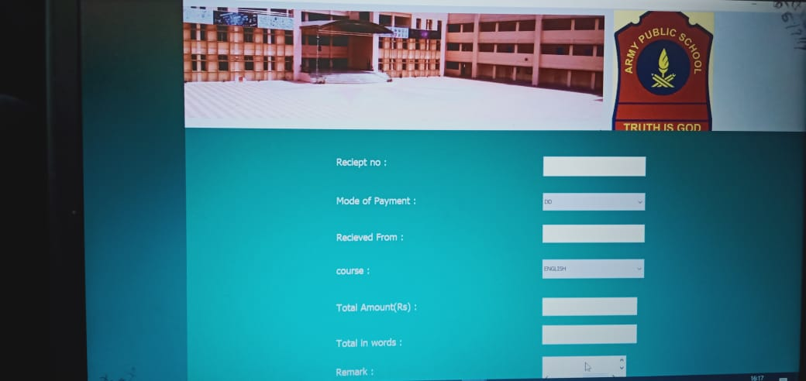

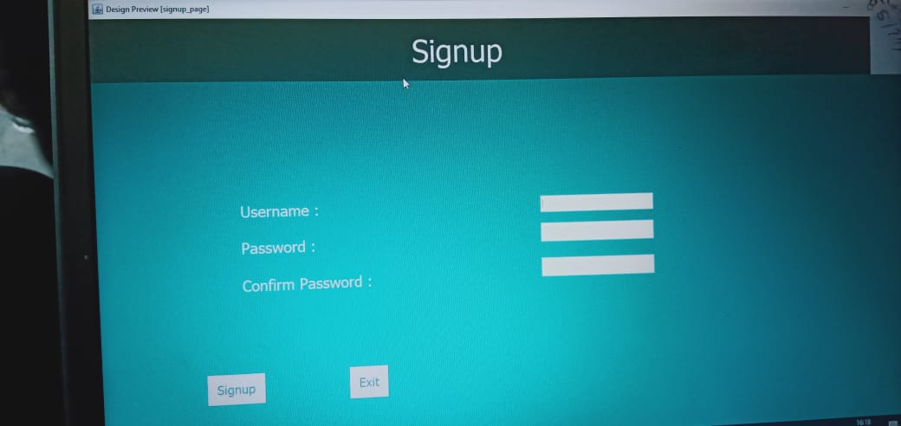

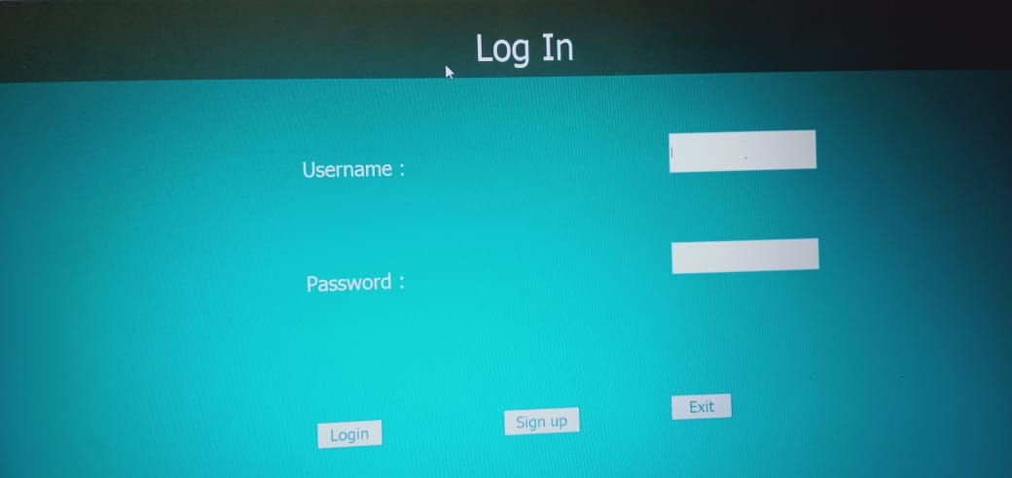

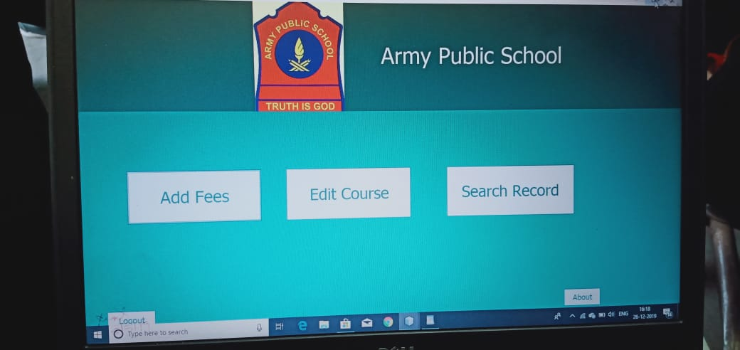

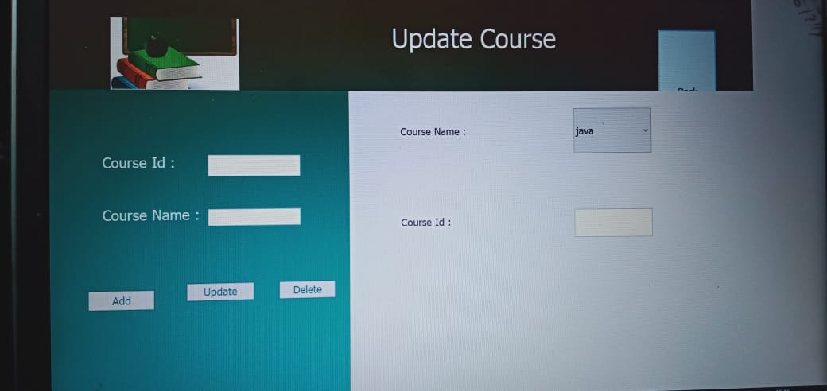

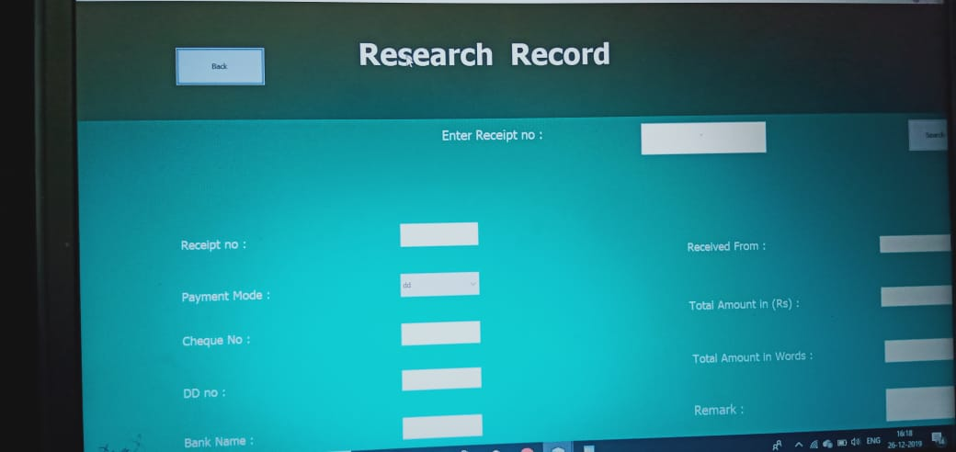

**System Security**

* Only authorized employee can access that software.
* Project is protected with login page which make sure employee or admin is authenticated before accessing secured files.
* Role based security model make sure, only administrative user’s can access Admin Control Panel.

**Limitation Of Project**

This project will be useful for any Feess and colleges with slightly modification. It may be used for English Medium Fees as well as Hindi Medium Feess. Project is flexible i.e. any change / modification in data base may be perform easily. Also this project could be made web enabled.

This project may be upgraded with some more modules such as sports module, prize module, student attendance module, employee salary module, annually receipt and expenditure reports generation etc. This project can also be made for multi-user environment.

**Future Scope and further enhancement**

The scope of the Fees management system facilitate us in the following jobs :-

* Maintaining Student Records
* Automatic Preparation of Marksheet
* Automatic updation in student TC
* Library Managenent

**BIBLIOGRAPHY**

1. An Introduction to Databse Management System by “Bipin C Desai”.
2. Software Engineering by “Roger S. Pressman”..
3. Software Engineering by “Jalote”.
4. PL/SQL by “Evan Barros”.
5. An Introduction to Databse Management System by “C. J. Date”.
6. Databse Concepts by “Korth, Silbertz”
7. Guide to Visual Basic 6.0 by “Nortan & Groh”